PSSI Science Project Reporting Template

️ | The PSSI Implementation Team is compiling a technical report to demonstrate the important research and advancements made by the Science Branch through the PSSI funding. The technical report will include a 3-4 page summary (including graphics and figures) for each project to show their key results and findings. Please fill in the following fields and sections for your project to be included in the report. Feel free to include and draw from any reports or presentations previously created through your research.  A plain language science bulletin will also be created to follow up on last year’s “DFO Pacific Region Science Bulletin, 2024. New research and monitoring for Pacific salmon and their ecosystems.” While the first bulletin introduced project backgrounds, methods, and timelines, this new bulletin will highlight the projects’ results, key findings, and conclusions with links to reports and data available. The bulletin will include a 1-2 page summary for each project gleaned from the content entered below.  ️ Completed forms are due January 7, 2026.  *Please include or send separately any graphics or pictures (with photo credits) that will help promote the projects.

PART 1: PROJECT METADATA

General Project Information
Project ID (number) | Project Title
Click or tap here to enter text. | Characterizing and monitoring priority contaminants of concern in WCVI juvenile salmon
Project Leads | Collaborations and External Partners
Lisa Loseto (prev. T. Brown) | Dr. T. Brown, SFU  Follow the Fish Program and associated partners and nations/organizations:: Huu-ay-aht First Nation, Toquaht Nation, Uchucklesaht Tribe, Hupačasath First Nation, Yuułuʔiłʔatḥ Government and Tseshaht First Nation
Location (if applicable)
WCVI, Barkley, Clayoquot Sound

Geographic and Stock Information
Salmon species (if applicable) | Waterbodies (if applicable)
Chinook | Barkley Sound, Clayoquot Sound
Life history phases (if applicable) | Region
Juvenile | WCVI
Stock (if applicable) | Population (if applicable)
Robertson | Click or tap here to enter text.
Conservation Unit (if applicable)
Click or tap here to enter text.

🧰 PART 2: PROJECT METRICS

Project Outputs
Include any anticipated outputs denoted as (in progress). Please include links to any outputs available online so they can be referenced in the report.
List scientific publications and technical reports (with links)
Noël, M., Loseto, L.L., Colbourne, K., Bartlett, M., Bokvist, J., and Brown, T.M. 2025. Contaminant concentrations in juvenile Chinook salmon (Oncorhynchus tshawytscha) collected from Barkley Sound, West Coast Vancouver Island, British Columbia, in 2022. Can. Tech. Rep. Fish. Aquat. Sci. 3655: vii + 31 p. https://doi.org/10.60825/7pxg-md57
List datasets generated (with links)
Click or tap here to enter text.
Describe dataset locations and data management systems
Using MS Excel Spreadsheets (saved on MS Teams SharePoint, DFO drives)

List code, programs, or other software created (with links)
Click or tap here to enter text.
List communication or social media products
FtF newsletter
List and describe field work completed
Fieldwork was led by Follow the Fish, who shared samples with our project.
List and describe samples collected/analyzed (number of samples)
Contaminant analyses:
2022: Two composites of n=5 and n=7 analyses for 12 contaminant classes, with over 700 analytes. The 12 classes included: legacy and current use pesticides, polychlorinated biphenyls (PCBs), polybrominated diphenyl ethers (PBDEs), dioxins and furans, per- and polyfluoroalkyl substances (PFAS), polycyclic aromatic hydrocarbons (PAHs), pharmaceutical and personal care products (PPCPs), alkylphenols, hexabromocyclododecane (HBCDD), polychlorinated paraffins, brominated and chlorinated flame retardants and metals including mercury.

Samples were collected in July and ranged in size from 78 to 109mm and 5.5 to 27g in weight.

The next set of analyses focused on examining a seasonal approach to characterizing the top 3 contaminant classes: PCBs, PAHs and metals, in particular mercury, in fish collected from both purse and seine needs from August to March – to capture the seasonality and size classes.

2023: n= 9 from Barkley Sound and n = 10 from Clayoquot Sound – all analyzed for metals including mercury, n=10 for PCBs and n = 10 for PAHs
2024: n= 40 from Barkley Sound and n = 20 from Clayoquot Sound all analyzed for metals including mercury, n=11 for PCBs and n = 11 for PAHs
List and describe large capital assets or equipment acquired
nil

PART 3: WRITTEN CONTENT

Highlights
Please summarize in 2-3 bullets:
- The main idea of the project
- Key findings
- Implications of these findings for salmon and decision-makers
- For a more technical audience, but still as plain language as possible
- The goal of the project was to better characterize contaminant levels and evaluate their potential impacts on the health of juvenile Chinook from the West Coast of Vancouver Island.
- 12 contaminant classes were analyzed in two composite samples collected in 2022 from Barkley Sound (completed) and polychlorinated biphenyls (PCBs), polycyclic aromatic hydrocarbons (PAHs) and metals were analysed in individual fish collected in 2023 and 2024 in Clayoquot Sound and Barkley Sound (in progress).
- Metals, PAHs, and PCBs were the top three contaminant classes detected with the highest concentrations in the two composite samples from Barkley Sound.
- Comparing our results to established effects thresholds, juvenile Chinook salmon from Barkley Sound may be at low risk of exposure to contaminants, specifically PCBs, PBDEs, Dichlorodiphenyltrichloroethane (DDT), PAHs and mercury.
- Concentrations of contaminant classes measured in WCVI juvenile Chinook Salmon range from 3 to 100x lower than levels of contaminant classes documented in juvenile Chinook in the Fraser River. As such contaminant levels in WCVI juvenile provide a benchmark of ‘lower’ levels reflecting lower urban and industrial associated sources.

Background
Please provide 1-2 paragraphs to summarize
- The relevant biological, environmental, and/or management context
- What knowledge gap or demand were you trying to fill?
- Collaboration and partner relationships
The marine environment is under significant anthropogenic pressures including overfishing, habitat degradation shipping, climate change and contaminants (Quinn, 2018). Although declines in Chinook salmon abundance are thought to be linked to freshwater, estuarine and marine environmental conditions, contaminants may also play a role, especially exposure to contaminants during their early life stage. For example, exposure to contaminants in freshwater and/or estuaries have been shown to impact growth and survival of juvenile Chinook salmon (Lundin et al., 2019, 2023; Zabel et al., 2004; Meador et al., 2014).
A variety of contaminants have been detected in adult Chinook salmon collected from the West Coast of Vancouver Island (WCVI) (Holbert et al., 2024). Some of the highest concentrations (on a lipid weight basis) of alkylphenols (APs), total hexachlorocyclohexane (HCH), short chain chlorinated paraffins (SCCPs) and medium-chain chlorinated paraffins (MCCPs) have also been measured in WCVI adult Chinook relative to other stocks (Brown and Holbert, unpublished data). Juvenile salmon are exposed to a variety of contaminants during their seaward migration depending on the characteristics and anthropogenic activities of the watershed. In their study of hatchery-reared Chinook salmon, Meador et al. (2014) found that individuals transiting through contaminated estuaries had a survival rate that was 45% lower than for those transiting through uncontaminated estuaries. To better characterize contaminant levels and evaluate their potential impacts on the health of juvenile Chinook, we collected juvenile Chinook salmon throughout Barkley Sound on the WCVI in July 2022 to evaluate the levels of over 700 compounds from 12 different contaminant classes. In addition, PCBs, PAHs and metals were analysed in individual fish collected in 2023 and 2024 in Clayoquot Sound and Barkley Sound. This project was conducted in partnership with the Follow the Fish program.

️ Methods and Findings
Please insert a few paragraphs to summarize:
- Main methods used
- Products and tools produced
- Advancements in methodology, technology, and application
- Advancements in communication and knowledge transfer
- Key results and information generated
Field collections:
2022: In 2022, the FtF program carried out purse seine surveys to catch and sample juvenile Chinook in the nearshore marine waters of Barkley Sound. Whole fish were frozen in the field using liquid nitrogen and sent to the Pacific Science Enterprise Center, West Vancouver, BC, where they were stored at -80 until further analyses.

2023/2024: In 2023/2024, the FtF program carried out microtrolling surveys to catch juvenile Chinook during their first winter at sea. Surveys were conducted in various sounds along the West Coast of Vancouver Island and we received samples from Barkley Sound (n=19) and Clayoquot Sound (n=30) that were collected between October 2023 and March 2024. In addition, we received samples from the purse seine surveys conducted in Barkley Sound in August (n=16) and September 2024 (n=22). As for the 2022 samples, the subset of captured juvenile Chinook salmon retained were euthanized and had their fork lengths measured and a fin clip taken for genetic stock identification. Samples were frozen in the field and sent to the Pacific Science Enterprise Center, West Vancouver, BC, where they were stored at -80 until further analyses.

Analytical methods:
Samples: In 2022, fish were pooled into two composite samples to have enough material to conduct the analyses of 12 different contaminant classes.
In 2023 and 2024, a muscle subsample from each individual fish was analyzed.

Genetic Stock identification: Fin clips collected in the field were sent to the Molecular Genetics Lab to determine stock of origin of fish using genetic stock identification (GSI) and parentage-based tagging (PBT) methods (Beacham et al., 2018).

Contaminants:
Samples from 2022 were analyzed for 12 different contaminant classes: legacy and current use pesticides using high resolution mass spectrometry (HRMS), polychlorinated biphenyls (PCBs) using HRMS, polybrominated diphenyl ethers (PBDEs) using HRMS, dioxins and furans using HRMS, per- and polyfluoroalkyl substances (PFAS) using liquid chromatography mass spectrometry/mass spectrometry (LC-MS/MS) , polycyclic aromatic hydrocarbons (PAHs) using gas chromatography mass spectrometry (GC/MS), pharmaceutical and personal care products (PPCPs) using LC-MS/MS, alkylphenols using GC/MS, hexabromocyclododecane (HBCDD)using LC-MS/MS, polychlorinated paraffins using GC/MS, brominated and chlorinated flame retardants using GC/MS metals using inductively coupled plasma collision reaction cell mass spectrometry (CRC-ICPMS) and mercury using Cold Vapor Atomic Absorption Spectroscopy (CVAAS). All analyses, except metals and mercury which were conducted at ALS Canada Ltd., Burnaby, were conducted at SGS AXYS Analytical Ltd., Sidney, B.C. Samples were run alongside reference samples and blanks to evaluate method performance.
While all samples from 2023 (n=19) and 2024 (n=60) were analyzed for metals and mercury at ALS, a subset was run for PAHs (n=8 and n=16, respectively) and PCBs (n=8 and n=9, respectively) at SGS AXYS.

Stable isotopes: Samples were analyzed for carbon and nitrogen stable isotopes at the Freshwater Institute Biotracers Laboratory as described in Rosenberg et al. (2015). Briefly, subsamples were freeze dried and one mg of sample was loaded into tin capsules and analyzed using a Thermo Advantage V Plus continuous flow Isotope Ratio Mass Spectrometer coupled with a Costech 4010 Elemental Analyzer.

Collaborative Analyses:
- Otolith microchemistry: Otoliths were collected from the fish sampled and polished to prepare them for microchemical analysis using a laser and a mass spectrometer, called LA-ICP-MS, or ‘Laser Ablation Inductively Coupled Plasma Mass Spectrometry’. Results of this analysis show how concentrations of elements change in a fish during its entire life and help understand fish growth as well as differentiate between periods spent in the freshwater vs saltwater. This information can provide helpful life history information that can help interpret contaminant concentrations observed in juvenile fish.
- Biotoxins: In addition to chemical pollutants, juvenile Chinook are also exposed to biological contaminants such as biotoxins, poisonous chemicals produced naturally by certain types of marine phytoplankton. A subset of the fish analyzed in 2023 and 2024 were also analyzed for biotoxins by the DFO biotoxin team (Institute of Ocean Sciences). Together with information on chemical pollutants, it will provide a fuller picture of contaminant exposure in these juvenile fish.

Transcriptomics: RNA is being extracted from liver samples from the 2023 and 2024 fish for which we have matching contaminant data. Briefly, tissues are being homogenized with TRIzol reagent and a 3 mm diameter tungsten-carbide bead using a mixer mill. Isolated total RNA is being resuspended in diethyl pyrocarbonate-treated distilled deionized water (DEPC) and stored at -80°C. RNA concentrations are being confirmed through spectrophotometry and 1 µg of each sample is being used to produce cDNA with the High Capacity cDNA reverse transcription kit (Applied Biosystems).
In addition to three normalizer genes (ribosomal protein L8, beta actin and Coil domain-containing protein 84), we are looking at genes known to be impacted by contaminants (aryl hydrocarbon receptor, cytochrome p450, estrogen receptor and vitttelogenin) as well as genes markers of stress response (catalase, heat shock protein 27 and metallothionein).

Key Findings:
- In the 2022 juvenile fish from Barkley Sound, metals, PCBs and PAHs were the top three contaminants with the highest concentrations out of the 12 contaminant classes analyzed (Figure 1).
- Overall, the levels of contaminants were generally lower than those reported in previous studies which were conducted mostly in more urban areas like Puget Sound, WA, and Oregon (O’Neil et al., 2020; Anzalone et al., 2022; Lundin et al., 2021; Figure 2) aligning with the fact that the West Coast of Vancouver Island is relatively remote from any major urban or industrial centers.
- A recent study (Lo, 2026) has enabled comparison with juvenile chinook from Harrison stock collected from the Fraser River at an earlier life stage (March to June) and small size class (ranging from 0.3 to 4.8g) for comparison. Relative to contaminants measured in juvenile Chinook from Barkley Sound in July 2022, the levels of contaminants in Fraser River juveniles were higher for example, levels of PCBs were up to 6x higher, PPCPs were nearly 100x higher, Alkylphenols were approximately 20x higher, and pesticides approximately 10x higher with PFAS and PBDEs approximately 3x higher (Lo, 2026).
- When comparing WCVI Robertson Creek juvenile Chinook concentrations to established effects threshold concentrations for contaminants (PCBs, PBDEs, DDT PAHs and mercury) and in fish (Meador et al., 2002; Berninger and Tillit, 2019; Arkoosh et al., 2017; O’Neill et al., 2015; Beckvar et al., 2005; Johnson et al., 2007), they are below all thresholds and therefore are likely at low risk contaminant associated effects due to these particular contaminants. Even though all fish collected in 2022 were collected at the same time within Barkley Sound, some differences in concentrations and patterns for some contaminants were observed between the two composite samples and may reflect variability of contaminant exposure related to the locations where they were collected in Barkley Sound or variability amongst individuals selected for each of the composite (influence of size).
- Preliminary results from 2023 and 2024 support this conclusion as monthly variability were observed in mercury concentrations and levels were correlated with length (Figures 3 and 4).

Insights
Please insert a few paragraphs to summarize:
- What this project has added to knowledge about salmon populations, health, or ecosystems.
- How this project informs salmon management:
  - decisions
  - policy guidance
  - trade-offs
  - planning
- Addition of knowledge to understanding:
  - limiting factors/stressors/threats/ pathways of effects/risks
  - biologically significant thresholds
  - cumulative impacts
- Sources of uncertainty
- We have characterized, for the first time, contaminant concentrations in juvenile Chinook salmon from the West Coast of Vancouver Island. Our results indicate a low risk of contaminant associated health impacts for certain compounds and contaminant classes. However, concentrations in juvenile Chinook suggest that WCVI juvenile Chinook are exposed to moderate levels of contaminants, relative to other regions in B.C. and Washington State and, it is therefore important to evaluate contaminant associated risks in juvenile Chinook inhabiting these waters.
- Management questions addressed by this project include those related to understanding and mitigating a significant stressor (i.e., contaminants) on at-risk salmon populations. Similarly, the recovery of Endangered Southern Resident killer whales and Threatened Northern Resident killer whales requires identifying and mitigating the significant threat posed by contaminants, and largely delivered via their priority prey, Chinook salmon.

⏩ Next Steps
Please insert 1-2 paragraphs to summarize:
- Remaining knowledge gaps and recommendations for future studies
- How can/should the project findings be operationalized for salmon conservation and management?
- Interpretation of the contaminant results for the 2023, 2024 samples.
- Combine contaminant dataset with transcriptomic dataset to evaluate the impacts of contamination, both chemical and biological (biotoxins) on the health of juvenile Chinook salmon.
- Interpretation with contaminated juvenile chinook from the Harrison stock collected from the Fraser River (Lo, 2026), that reflect exposure to sources in highly urbanized and industrialized habitats
- Finding from our study may provide benchmarks for low contaminant levels and an associated no to low effects that other managed areas need to strive towards, in particular providing contextual comparisons to the Fraser River stocks.

📈 Tables and Figures
Please provide captions and numbering for any tables and figures. Graphics can be copied below or e-mailed separately.
- Include a brief caption with each figure and table in the box below
- Number each table and figure, and include references in the above sections where appropriate.
- 1-3 figures are recommended per project
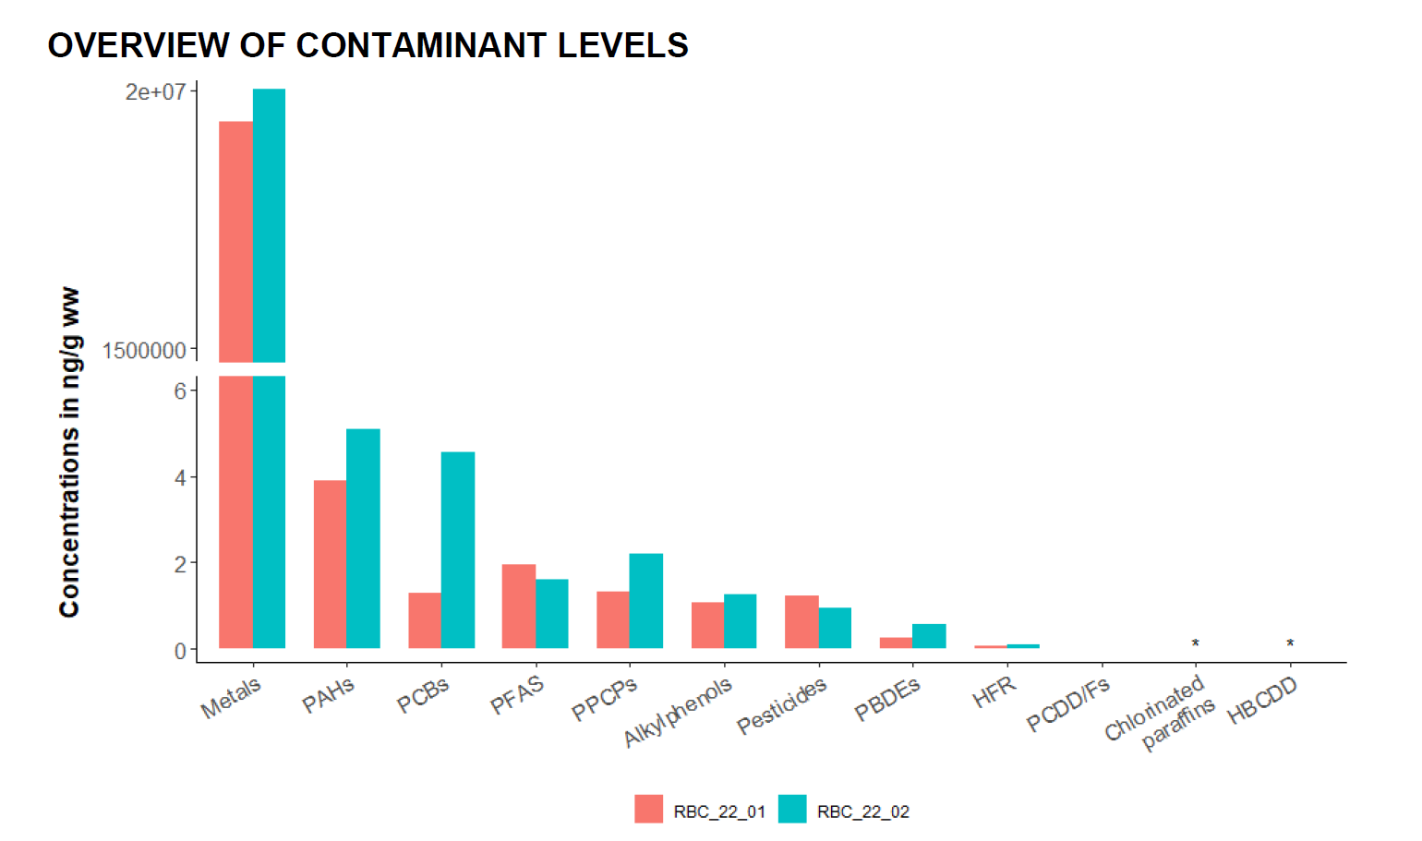

Figure 1: Total concentrations (ng/g wet weight (ww)) of each contaminant class analyzed in the two juvenile Robertson Creek Chinook salmon composite samples collected in 2022 ranked from highest to lowest. * indicates contaminants not detected

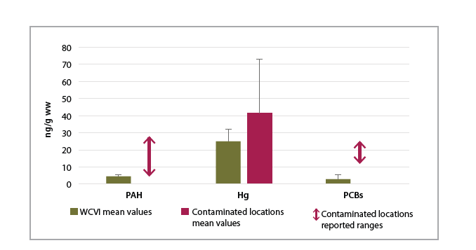
Figure 2. Concentrations in the top three contaminants in WCVI 2 composites relative to published studies of levels in juvenile Chinook salmon living in highly urbanized areas.

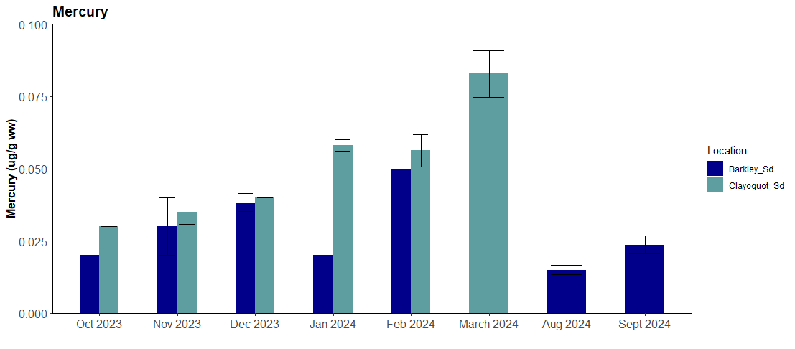

Figure 3. Temporal trends in mercury (ug/g ww) in WCVI juvenile salmon collected in Barkley Sound and Clayoquot sound in 2023 and 2024.

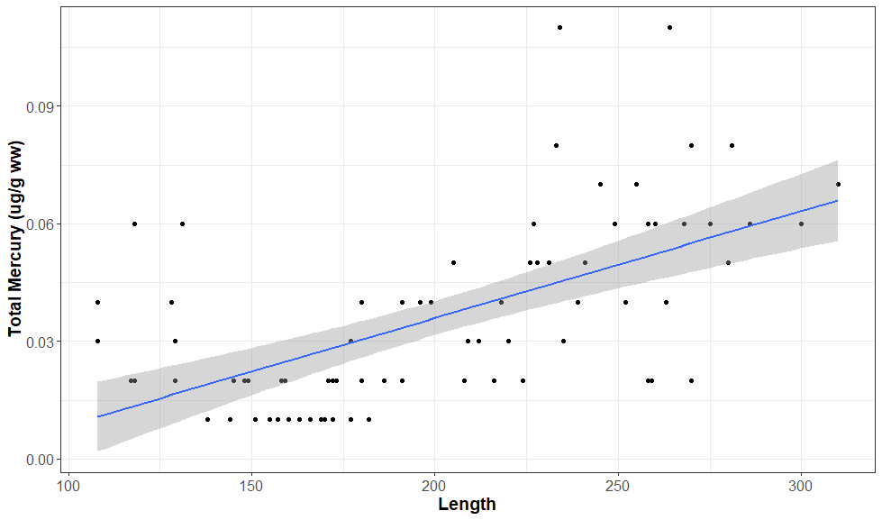

Figure 4. Significant positive relationship with juvenile Chinook salmon whole body mercury (ug/g ww) and length (p < 0.05, R – 0.36), for individuals collected from August to March (2023, 2024).

📈 References
Include full references for any publications referenced in other sections. Please format references in Harvard style according to Instructions to Authors for the Canadian Journal of Fisheries and Aquatic Sciences, at Canadian Science Publishing.
Click or tap here to enter text.
Anzalone, S. E., Fuller, N. W., Hartz, K. E. H., Fulton, C. A., Whitledge, G. W., Magnuson, J. T., ... & Lydy, M. J. (2022). Pesticide residues in juvenile Chinook salmon and prey items of the Sacramento River watershed, California–a comparison of riverine and floodplain habitats. Environmental Pollution, 303, 119102.
Arkoosh, M. R., Van Gaest, A. L., Strickland, S. A., Hutchinson, G. P., Krupkin, A. B., & Dietrich, J. P. (2017). Alteration of thyroid hormone concentrations in juvenile Chinook salmon (Oncorhynchus tshawytscha) exposed to polybrominated diphenyl ethers, BDE-47 and BDE-99. Chemosphere, 171, 1-8.
Beacham, T.D, Wallace, C., MacConnachie, C., Jonsen, K., McIntosh, B., Candy, J.R., & Whitler, R.E. (2018). Population and individual identification of Chinook salmon in British Columbia through parentage-based tagging and genetic stock identification with single nucleotide polymorphisms. Canadian Journal of Fisheries and Aquatic Sciences, 75(7), 1096-1105.
Beckvar, N., Dillon, T. M., & Read, L. B. (2005). Approaches for linking whole‐body fish tissue residues of mercury or DDT to biological effects thresholds. Environmental Toxicology and Chemistry, 24(8), 2094-2105.
Berninger, J. P., & Tillitt, D. E. (2019). Polychlorinated biphenyl tissue‐concentration thresholds for survival, growth, and reproduction in fish. Environmental toxicology and chemistry, 38(4), 712-736.
Holbert, S., Colbourne, K., Fisk, A. T., Ross, P. S., MacDuffee, M., Gobas, F. A. P. C., & Brown, T. M. (2024). Polychlorinated biphenyl and polybrominated diphenyl ether profiles vary with feeding ecology and marine rearing distribution among 10 Chinook salmon (Oncorhynchus tshawytscha) stocks in the North Pacific Ocean. Environmental Research, 241, 117476.
Johnson, L. L., Ylitalo, G. M., Sloan, C. A., Anulacion, B. F., Kagley, A. N., Arkoosh, M. R., ... & Collier, T. K. (2007). Persistent organic pollutants in outmigrant juvenile chinook salmon from the Lower Columbia Estuary, USA. Science of the Total Environment, 374(2-3), 342-366.
Lundin, J. I., Spromberg, J. A., Jorgensen, J. C., Myers, J. M., Chittaro, P. M., Zabel, R. W., ... & Scholz, N. L. (2019). Legacy habitat contamination as a limiting factor for Chinook salmon recovery in the Willamette Basin, Oregon, USA. PLoS One, 14(3), e0214399.
Lundin, J. I., Chittaro, P. M., Ylitalo, G. M., Kern, J. W., Kuligowski, D. R., Sol, S. Y., ... & Scholz, N. L. (2021). Decreased growth rate associated with tissue contaminants in juvenile Chinook salmon out-migrating through an industrial waterway. Environmental Science & Technology, 55(14), 9968-9978.
Lundin, J. I., Chittaro, P. M., Schultz, I. R., Arkoosh, M. R., Baker, M. C., Baldwin, D. H., ... & Dietrich, J. P. (2023). Dietary Exposure to Environmentally Relevant Levels of Chemical Contaminants Reduces Growth and Survival in Juvenile Chinook Salmon. Environmental Science & Technology, 58(1), 132-142.
Meador, J. P., Collier, T. K., & Stein, J. E. (2002). Use of tissue and sediment‐based threshold concentrations of polychlorinated biphenyls (PCBs) to protect juvenile salmonids listed under the US Endangered Species Act. Aquatic Conservation: Marine and Freshwater Ecosystems, 12(5), 493-516.
Meador, J. P. (2014). Do chemically contaminated river estuaries in Puget Sound (Washington, USA) affect the survival rate of hatchery-reared Chinook salmon?. Canadian Journal of Fisheries and Aquatic Sciences, 71(1), 162-180.
O’Neill, S. M., Carey, A. J., Lanksbury, J. A., Niewolny, L. A., Ylitalo, G., Johnson, L., & West, J. E. (2015). Toxic contaminants in juvenile Chinook salmon (Oncorhynchus tshawytscha) migrating through estuary, nearshore and offshore habitats of Puget Sound. Washington Department of Fish and Wildlife Report FBT, 2-16.
O'Neill, S. M., Carey, A. J., Harding, L. B., West, J. E., Ylitalo, G. M., & Chamberlin, J. W. (2020). Chemical tracers guide identification of the location and source of persistent organic pollutants in juvenile Chinook salmon (Oncorhynchus tshawytscha), migrating seaward through an estuary with multiple contaminant inputs. Science of the Total Environment, 712, 135516.
Quinn, T.P., 2018. The abundance and diversity of salmon and trout: Past, present, future. In: The Behavior and Ecology of Pacific Salmon and Trout. University of Washington Press.
Rosenberg, B., Neumann, D., & Loseto, L. (2015). Freshwater Institute (DFO Winnipeg) Stable Isotope Laboratory Quality Assurance/Quality Control and Inter-lab Comparison Report. Fisheries and Oceans Canada= Pêches et océans Canada.
Zabel, R. W., & Achord, S. (2004). Relating size of juveniles to survival within and among populations of Chinook salmon. Ecology, 85(3), 795-806.

